Student Name: __________________
Class and Section __________________
Total Points (20 pts) __________________
Due: Feb 7, 2010 before the class

Project: Displaying Words in Ascending Alphabetical Order

CSCI 2410 Data Structures and Algorithms
Armstrong Atlantic State University

Problem Description:

Write a program that reads words from a text file and displays all the words (duplicates allowed) in ascending alphabetical order. The words must start with a letter. The text file is passed as a command-line argument. Here is a sample run:

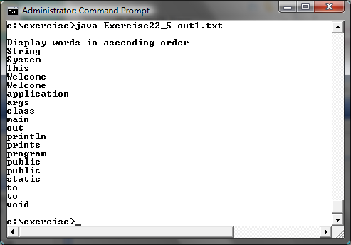

Paste your source code here:

Screen shots:

What to submit?

1. This document

2. Sava/Compile and Submit to LiveLab (you must submit the program regardless whether it complete or incomplete, correct or incorrect)

Fill in self-evaluation:

- Can your program display words only? _______________
- Can your program display words in increasing order? _______________
- Can your program display duplicate words? _______________
- Can your program pass argument from the command-line? _______________

